SNOHOMISH COUNTY FIRE DISTRICT NO. 5
Commissioners Meeting Agenda

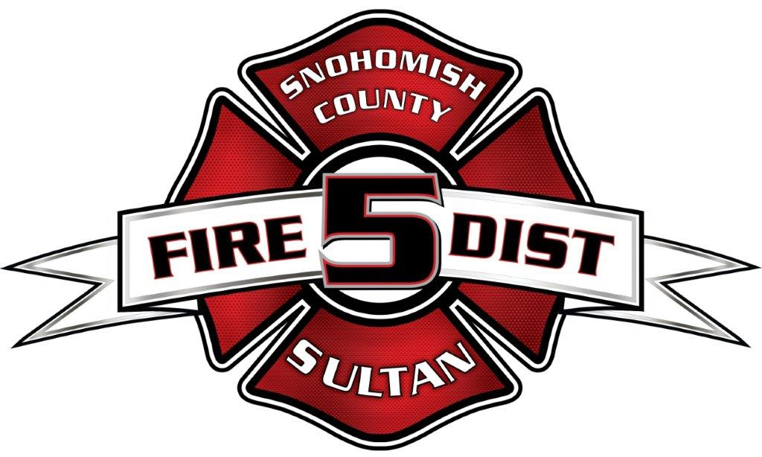

SPECIAL MEETING

October 10 , 2025

CALL TO ORDER

NEW BUSINESS
Attorney Brian Snure Seminar regarding - Fire District Mergers, and Regional Fire Authorities (educational purposes) - Fire Station 53, 501 Lewis St. Gold Bar

ADJOURN

